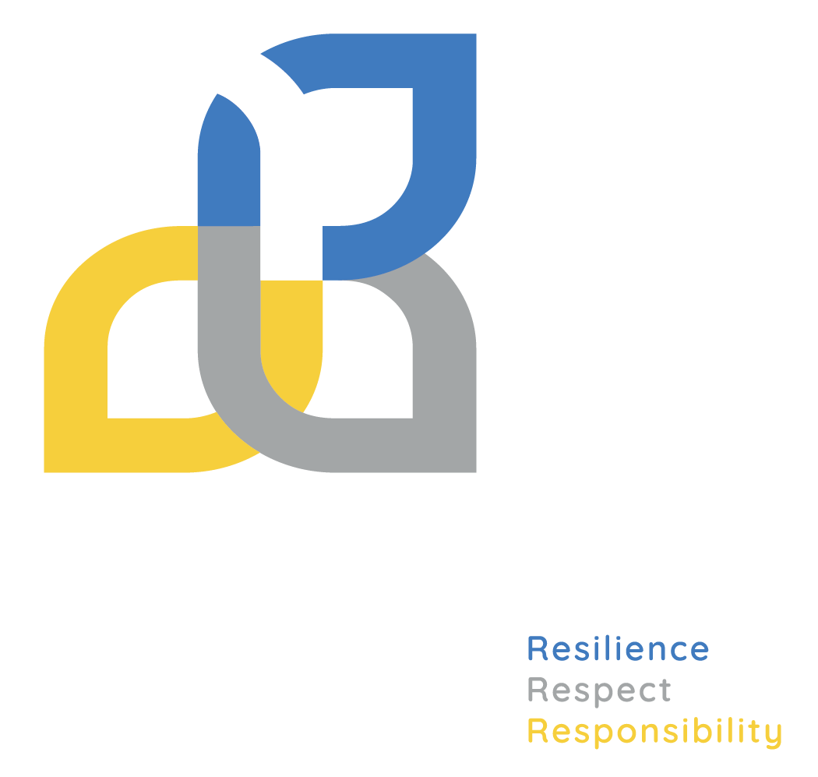
NDIS Navigators – Advice for parents and carers
The Department of Education is committed to supporting children with disability and their families. That is why we are introducing National Disability Insurance Scheme (NDIS) Navigators in all Victorian government specialist schools.
NDIS Navigators can help you to:
- navigate and understand the NDIS
- apply for and access NDIS funded supports for your child
- understand activities like a plan reassessment.
- find out how to raise issues about your child’s plan or with a provider.
NDIS Navigators will not:
- contact the NDIS or NDIS funded therapists, or complete applications and paperwork on your behalf, but they can help you to do these things yourself
- provide individual student case management or crisis management
- recommend or make referrals to specific NDIS service providers.

When will NDIS Navigators be available at my school?
NDIS Navigators will start working in some Victorian government specialist schools in 2023, with more schools having an NDIS Navigator in 2024. Every Victorian government specialist school will have an NDIS Navigator by 2025.
Your school will let you know when the NDIS Navigator is available.

Who does the NDIS Navigator work for?
The NDIS Navigator is employed by the school and works at the school. They do not work for the National Disability Insurance Agency or any NDIS funded agency.

How can I talk to an NDIS Navigator?
Once your school has an NDIS Navigator they will give you information on how to get in touch.
The NDIS Navigator is available only during term time. They may be able to meet with you in person, online or talk over the phone.

Does it cost money to speak to the NDIS Navigator?
No, there is no charge for the NDIS Navigator’s services to you.

Do I have to get advice from the NDIS Navigator?
The NDIS Navigator’s services are completely optional. You do not need to speak to the NDIS Navigator to get support for your child from the NDIS or your school.

How do I find out more information?
For further information about the NDIS Navigator, contact your school.

